Garmin

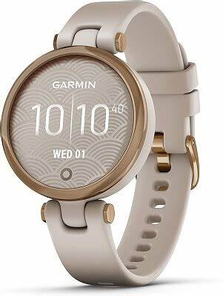

Description: **Garmin** is a leading brand known for its innovative, high-performance smartwatches and fitness trackers, designed to combine functionality, durability, and technology. While not as traditional in luxury as some other brands, Garmin has gained popularity for its **advanced features**, especially in the realms of **fitness, health, and outdoor activities**, making it a great choice for active women who appreciate both style and cutting-edge technology.

One of Garmin's standout collections for women is the **Garmin Venu** series. These watches feature vibrant **AMOLED touchscreens** and are designed to track a wide range of health and fitness metrics, including **heart rate, stress levels, sleep tracking, and step counts**. With a sleek design, available in **small and medium sizes**, the Venu is perfect for women who want a smartwatch that’s both functional and stylish, with customizable watch faces and interchangeable straps to match different outfits.